Part A — Use Case & Problem Statement

1. Problem statement
When I sit and study at a desk, can a single PIR sensor (HC-SR501) reliably report whether the room is occupied — the very signal that automatic lighting and air-conditioning systems rely on to decide whether to switch on or off?

2. Why it matters
Smart-building systems use occupancy signals to save energy, and HVAC accounts for 25–50% of a building’s energy use (Franco et al., 2025). If the sensor wrongly reports “empty” while someone is still present, the system dims the lights and throttles cooling or heating on the occupant — causing discomfort and making equipment cycle out of step with real need. Stakeholders include the room user, facility managers, and the university’s sustainability targets. The result tells us whether a common, low-cost occupancy sensor is genuinely fit for automatic control in a study space.

3. Expected outcome
I expect the PIR to read HIGH (“occupied”) for the entire time I am present. I test that expectation under realistic study conditions — with natural stretches of sitting still interleaved with movement — to see whether the PIR sustains an “occupied” signal when I am not moving. If the expectation proves wrong, that itself is the valuable finding.

Part B — Sensor & Protocol Design

1. Sensors selected
HC-SR501 ((PIR Motion Sensor) — primary sensor. The most common and cheapest passive-infrared occupancy sensor available, making it both a sensible choice and a worthwhile subject to test. It detects people by sensing changes in infrared radiation across its field of view — so it depends on the movement of a heat source. Specifications: digital HIGH/LOW output; detection range ~3–7 m (trimpot-adjustable); ~110° cone; supply 4.5–20 V; sensitivity and hold-time trimpots; ~60 s warm-up after power-on.
DHT22 (Temperature & Humidity Sensor) — contextual (secondary) sensor. The DHT22 does not directly answer the occupancy question; it records environmental conditions (temperature, humidity) during the session and provides continuous data for descriptive statistics and visualisation. Specifications: temperature −40 to 80°C, accuracy ±0.5°C; humidity 0–100%, accuracy ±2–5%; minimum read interval ~2 s.

2. Data capture setup
- Hardware: An Arduino Nano 33 IoT board will be connected to the HC-SR501 and DHT22, then tethered to a laptop via USB.
- Communication: Data will be transmitted to the laptop via the Serial port ( COM 9 )
- Sampling frequency: DHT22 every 2 s (the sensor’s physical minimum); PIR logged on state-change events
- Duration: The capture session will run continuously for 31.6 minutes. This duration is long enough to allow the user to settle into deep, motionless focus
- Timestamp: arduino_ms (Arduino millis()) as the primary time source, plus a pc_datetime from Python
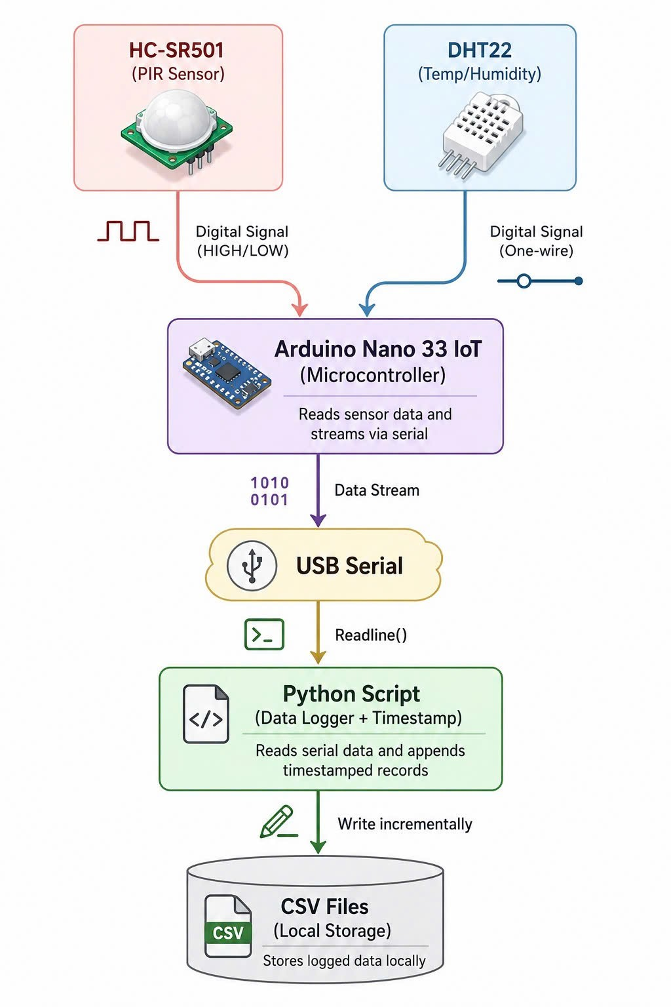

3. Local processing & storage
Arduino streams data over serial; a Python script receives it, adds a timestamp, and writes incrementally to CSV. Two streams are stored separately — a PIR file (arduino_ms, state) and a DHT file (arduino_ms, humidity, temperature) — and joined on arduino_ms.
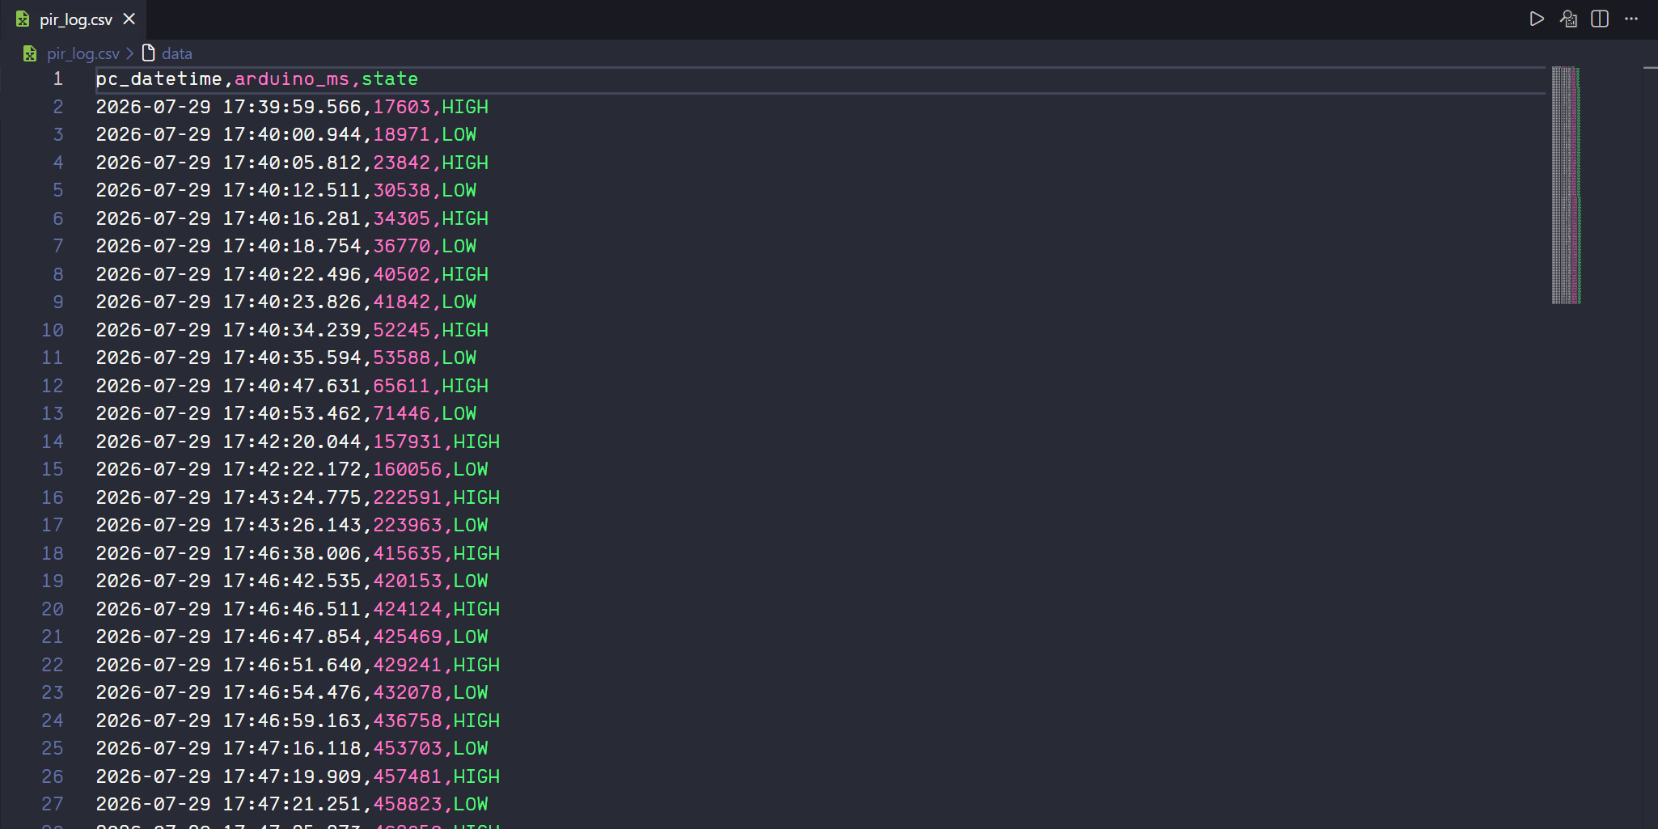
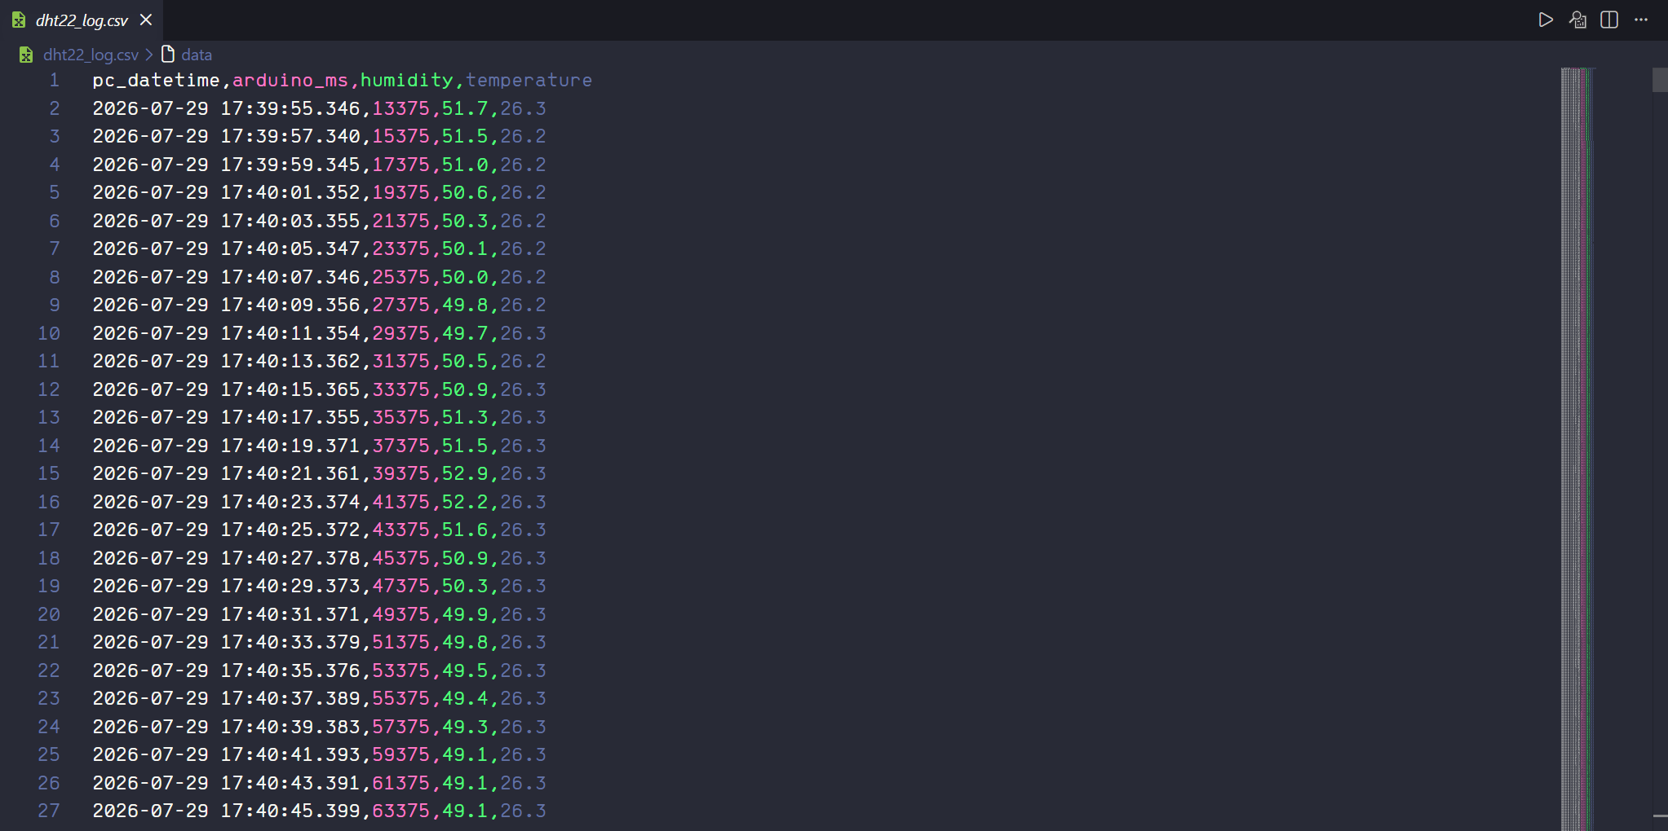

4. Ground-truth protocol
The session followed a pre-defined activity script so that actual presence could be compared against the PIR signal. This script provides the ground-truth column used to compute the PIR error rate.
Minute | Activity | Actual
0–1 | Sit down, keep still (warm-up) | (discarded)
1–6 | Sit still, reading / light typing | Present
6–9 | Move: reach, swivel chair, stand | Present
9–15 | Sit still, focused | Present
15–18 | Leave the room | Absent
18–24 | Return, normal work | Present
24–30 | Sit still, final block | Present

5. Data quality checks
- Discard the first ~60 s of PIR warm-up.
- DHT22: drop failed/NaN reads; discard values outside a plausible indoor range (<10°C or >40°C) — none occurred.
- pc_datetime carries only minutes:seconds and wraps every 60 minutes — replaced by arduino_ms.

Part C — Implementation & Data Capture
The following items are submitted with this report:
- Arduino .ino sketch (reads PIR + DHT22, prints to serial, fully commented) :

- Python script (opens serial connection, adds timestamp, writes CSV):

- CSV data file:

1P_pir_with_groundtruth.csv:
The raw of PIR file
The raw DHT file:
- Screenshot of the serial monitor / console as proof of capture:
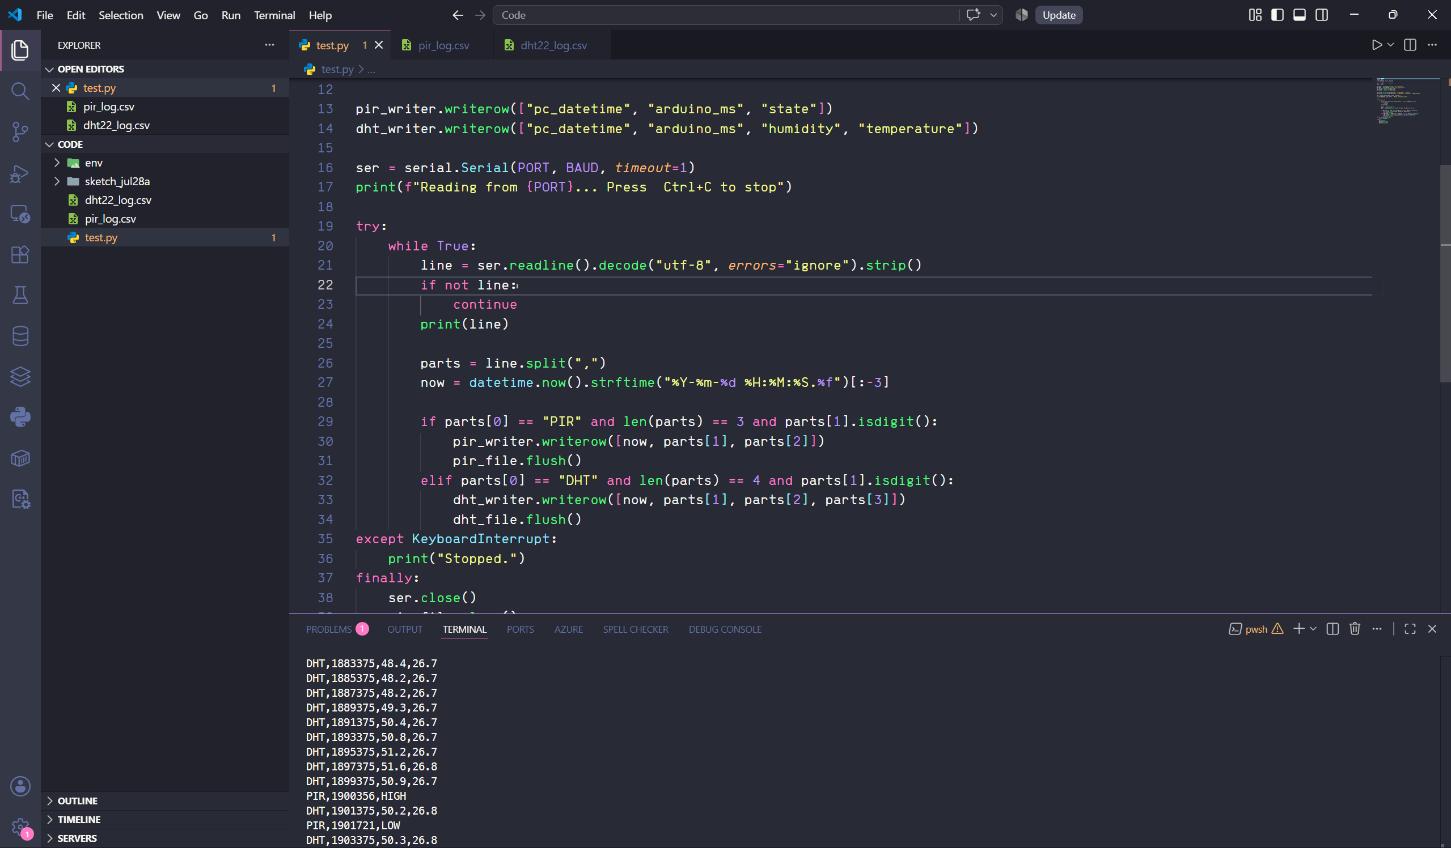

Part D — Analysis & Visualisation

1. Load & inspect
Both CSV files were read into Pandas and joined on arduino_ms. The session comprises ~945 DHT samples (every 2 s) and 146 PIR state-change events across 31.6 minutes. DHT22 descriptive statistics (contextual): temperature 26.0–26.8°C (range only 0.8°C — very stable) and humidity 47.9–53.3% (mild fluctuation around 49–50%). The environment was stable throughout, confirming that no environmental factor confounded the PIR analysis.

2. Visualisations
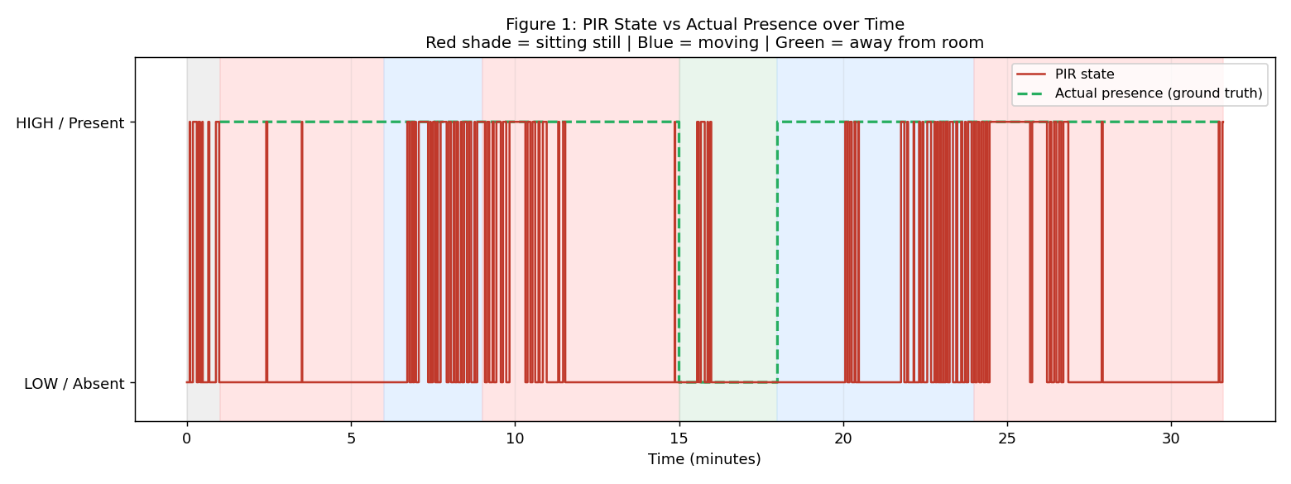
Figure 1. PIR state (red) vs actual presence (green dashed) over time; background shaded by activity phase. The PIR repeatedly drops to LOW during the still phases even though the occupant is present.
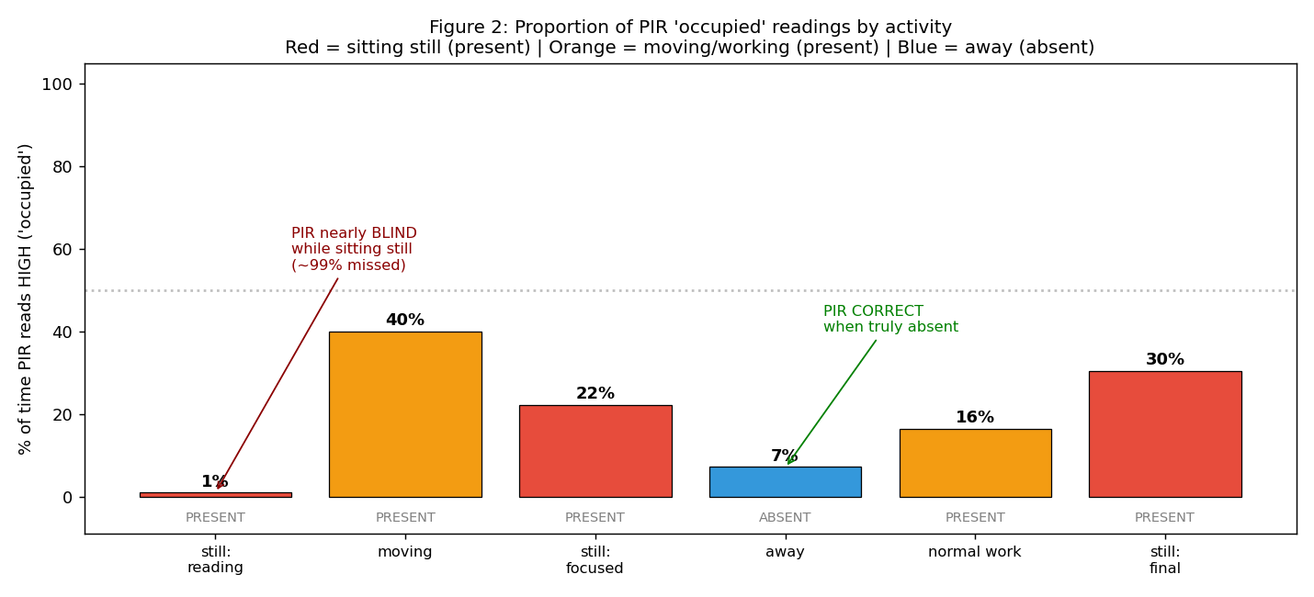
Figure 2. Proportion of PIR “occupied” readings by activity. The PIR is near-silent while sitting still (present) but reads correctly empty when the occupant is genuinely away.

3. Pattern analysis
The data decisively refutes the initial expectation. Across the whole session the PIR missed 78.7% of the time the occupant was present — reporting “empty” for 21.7 of the 27.6 minutes actually present. The per-phase breakdown makes the mechanism clear:
Phase | Actual | Seconds | PIR HIGH % | Missed %
Sitting still: reading | Present | 300 | 1.0% | 99.0%
Moving | Present | 180 | 40.0% | 60.0%
Sitting still: focused | Present | 360 | 22.2% | 77.8%
Away | Absent | 180 | 7.2% | —
Normal work | Present | 360 | 16.4% | 83.6%
Sitting still: final | Present | 456 | 30.5% | 69.5%

- Sitting still, reading (min 1–6): PIR HIGH only 1% of the time — 99% missed. The clearest demonstration of the blind spot.
- Moving (min 6–9): PIR HIGH 40% — higher, but not 100%, because movement was discrete (reach, then stop) and the PIR dropped straight back to LOW between actions.
- Leaving the room (min 15–18): PIR read empty 92.8% — the PIR is correct when the occupant is genuinely absent.
- Normal work and final still block: 84% and 70% missed.
The pattern is consistent: the PIR does not measure “is someone here”, it measures “was there just some motion”.

4. Written interpretation
I expected the PIR to sustain an “occupied” signal for as long as I sat in the room, but the data shows the opposite: the PIR reads HIGH only during clear motion and falls back to LOW almost immediately when I sit still. Over 27.6 minutes of presence the PIR missed 21.7 minutes — a false-negative rate of 78.7%. Notably, the PIR is highly accurate when I am truly absent (correct 92.8%), and when it does read HIGH it is almost always right (precision 96.4%). The PIR is not faulty; it is doing exactly what it is built to do — detect motion, not presence.
Does the data support the problem statement?
No. A single PIR sensor does not reliably report the presence of a stationary occupant. For desk-based work — where a person is still for most of the time — the PIR will repeatedly misreport “empty”, causing automatic control systems to switch off lighting or HVAC incorrectly.
Limitations:
(1) The evaluation was conducted with a single sensor, a single participant, and a single recording session, so the findings may not generalize to other users or environments.
(2) Performance is influenced by the sensitivity and hold-time settings of the HC-SR501 sensor.
(3) Ground-truth labels were generated from a predefined activity schedule, with minute 0 defined as the timestamp of the first recorded sample.
(4) The absent period still contained approximately 7% HIGH readings, likely caused by movement while the participant was leaving the monitored area.
(5) Since pc_datetime resets after 60 minutes, arduino_ms was used for the final analysis instead.
Refinement for the next iteration:
Add a distance sensor (HC-SR04 ultrasonic) running independently, detecting presence from “is there an object at the chair” rather than “is there motion”. Because it does not depend on movement, it should in principle fill the exact blind spot the PIR exposed here. This motivates the enhanced design explored in Assessment 2.

References
Franco, A., Crisostomi, E., Leccese, F., Mugnani, A., & Suin, S. (2025). Energy savings in university buildings: The potential role of smart monitoring and IoT technologies. Sustainability, 17(1), 111 https://doi.org/10.3390/su17010111

